SIL CONVERTERS IS NOW AVAILABLE IN THE
WINDOWS PORT AS OF VERSION 4.1.0 OF ADAPT IT WX

New Menu Items in support of SIL Converters in Adapt It
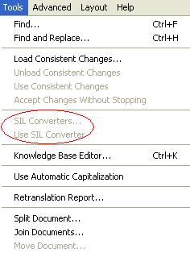
      - Tools, SIL Converters...
If SIL Converters v3.0 (or the previous version 2.2) is not installed on the user's machine, the menu item will be grayed out (as above). User's can download SIL Converters v3.0 from this website: http://scripts.sil.org/cms/scripts/page.php?site_id=nrsi&item_id=EncCnvtrs.
If enabled and the user clicks on this menu item, the following dialog box will be displayed. Initially, it will appear as below:
        - Choose SIL Converter Dialog:
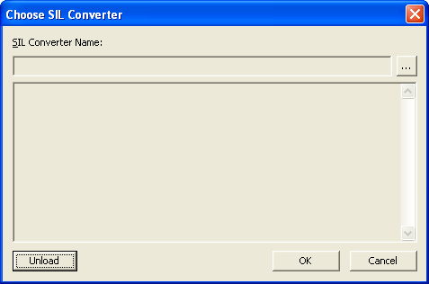
Figure 1: Empty Choose SIL Converter Dialog
To configure a SIL Converter, the user must click the "Select Converter..." browse button. When clicked, the following dialog box is displayed.
        - Choose an existing converter Dialog:
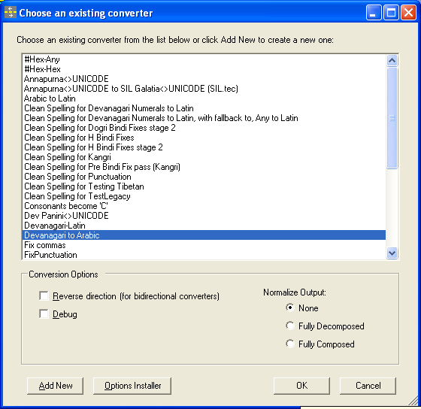
Figure 2: Choose an existing converter Dialog
This dialog shows which converters are installed in the system repository. There are three options from this point:
Add a new converter, which eventually leads you back to this same dialog. This button can be used to add a SIL Converter for any of the following conversion engines:
CC
TECkit
Perl expressions
Python script

Select a converter and click OK.
This action returns the user to the previous dialog box with the Converter name and details filled out:
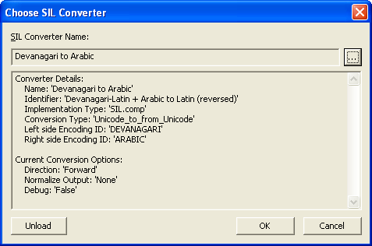
Figure 3: Filled out Choose SIL Converter Dialog
From here, if the user clicks OK, then the converter name will be saved in the project file and the next menu item (Use SIL Converter) will be enabled.
To remove the configured converter (c.f. Unload for the CC Processor), the user can click the Unload button.
This action returns the user to the previous dialog box with the Converter name and details blanked out (c.f. Figure 1: Empty Choose SIL Converter Dialog).
Cancel. This button cancels or closes the dialog without making any additional changes.
      - Use SIL Converter
If SIL Converters v3.0 (or v2.2). is installed, and if a converter is configured, then this menu item will be enabled.
When clicked, Adapt It will behave in an identical manner to Use Consistent Changes, but using the configured SIL Converter.


